 Progress = Infrastructure (aka "El 47")
Why is a movie about a bus to a suburb of Ba the most important reminder of what this is all about (or what it should all be about
OCT OS, 2024



1U
1
1
Com
Last night I left the theater feeling moved. Not only because of the extraordinary performances, the sublime screenplay, the perfect cinematography, and the well-crafted music, but also because the film served as a powerful reminder of what kind of public, collective decision-making can have the greatest impact on progress by improving people’s lives.
I won’t give anything away: I’ll just say that “El 47” is about the bus with that name and the battle to extend public transportation all the way to Torre Baró. But what is “up there”? It’s something like this (the photo is mine; I took it in Baró, another neighborhood on what was then the outskirts, at the start of summer).

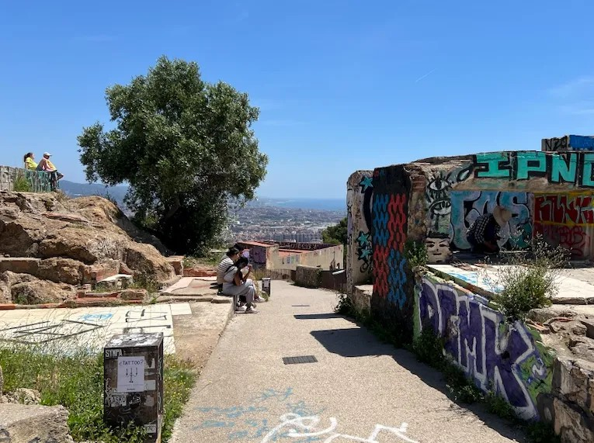

Over there on the left, you can see a plot of land. On the right, another one. They aren’t surrounded by walls. There are also some walls (now) without roofs. That area used to be home to a few self-built houses that families—mostly from Extremadura and Andalusia—constructed upon arriving in the 1950s. Further down, there’s a much larger neighborhood still standing.
And to situate Torre Baró in relation to the rest of Barcelona, let’s take Plaça Catalunya as a reference point.

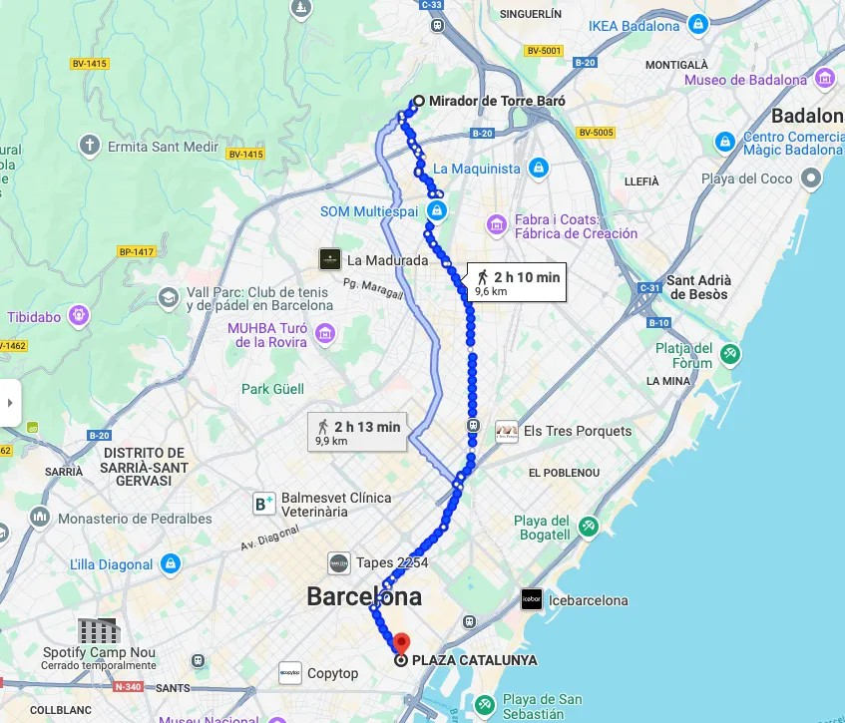

Almost 10 km. The neighborhood residents, whose jobs were down the hill, did all of this on foot. Or at least a good part of it: the entire descent to the nearest stop. Plus, of course, no services we can imagine reached the area properly. The film talks about all of them, but focuses on transportation. Now things are like this.

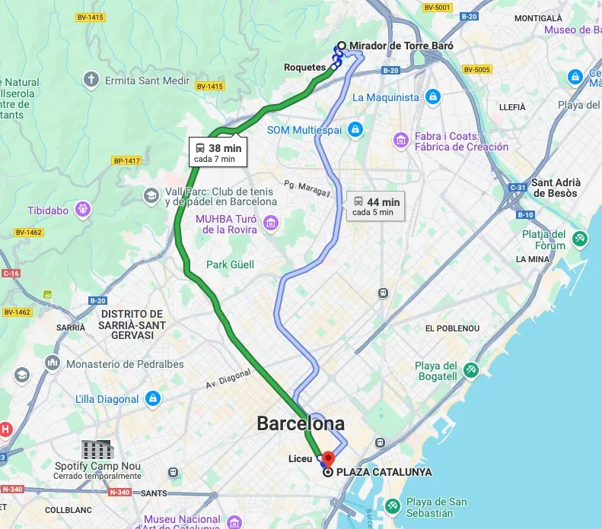

I won’t go into the many complexities the neighborhood went through here (though I encourage you to read about them); rather, I want to use this image to highlight the main lesson learned from “El 47”—or rather, as a reminder: if, out of all the things we can do collectively, we want to choose those that will make the biggest difference in people’s lives, let’s start with what can improve their material conditions. And to achieve that, the thing we agree on most is to take action.
Taking action is also quite useful from an eco-political perspective because it resolves part of the dilemma between winners

Losers: You don’t eliminate one bus route to replace it with another, nor do you move a school from one place to another. You add a bus or build a school. Of course, that doesn’t solve everything: the budget is limited, and you have to choose what to do. But I think that’s the kind of economic and political dilemma we want to face.
I’ll illustrate this with another example that couldn’t be more relevant. I wish the public debate would focus all its energy on discussing whether rent subsidies are better or worse than providing financial assistance to renters. It’s necessary to devote part of the public debate to these measures—which are already in place—and it’s essential to assess their effectiveness (I did just that here alongside Ángel Martínez and Natalia Collado). But shouldn’t we be investing more collective time and attention in where to create new affordable housing supply, and how to do it? With limited budgetary resources, the focus shifts to renovation or social housing; to whether they do it in this or that location. By the end of the decade, that’s what will remain. Not a measure that lasts just a few months or years per household.
Another example: Lucas Gortazar and I said here that the Spanish education system will likely have a more comfortable student-to-teacher ratio in the coming years as demographics empty our classrooms. But other issues are under pressure from unresolved problems: segregation, grade repetition, failure, lack of mathematical and scientific knowledge, school schedules that neither protect nor adequately support students or their parents… Shouldn’t we be discussing at length which of all these problems we’re going to invest that surplus in?
Let’s keep in mind that infrastructure isn’t just concrete or equipment like roads or train tracks—no. It’s also hiring people, training them, paying them

adequately (and hold them accountable accordingly) so they can provide the services we consider most necessary. It includes books, computer equipment, and healthy environments in schools. Infrastructure consists of tangible things that drive progress.
This may be raising two types of doubts (or more, but mainly two) for you right now:
- Doing things comes with costs beyond just the budgetary ones. We understand this much better now than we did 50 years ago, when the cost or the carbon footprint of an “extra” wasn’t properly measured. I have two answers: first, let’s factor these costs into the price (we’re already doing this, though we’re a bit behind—this will help us make more informed decisions; we’ll have to make it worthwhile). On the other hand, it goes without saying that investing in decarbonization infrastructure is one of the most important things I believe we need to do. As the report noted, eliminating emissions can make us more efficient. Also in
Any concrete examples of investment in this area? From renovating homes with insulation and low-emission heating systems to basic research on clean energy.
- There aren’t that many things left to do. Torre Baró achieved its goal, just like the rest of Barcelona’s outskirts, and Madrid’s. With more accessible healthcare and education systems that brought us closer to universal coverage. And to that I say: well, maybe there isn’t much left from your perspective, since you’re looking back from a less comfortable position. I’m not at all sure that if you go and ask someone living in one of the millions of homes with thermal insulation problems in Spain, they’ll tell you there isn’t much left to do. Or to a

someone at a completely overwhelmed health center with unsustainable patient-to-doctor ratios. In this graph by Cobreros and Carlos Sunyer, I see plenty to be done in very specific places: those with lower incomes, higher unemployment rates, and fewer healthcare professionals on hand.
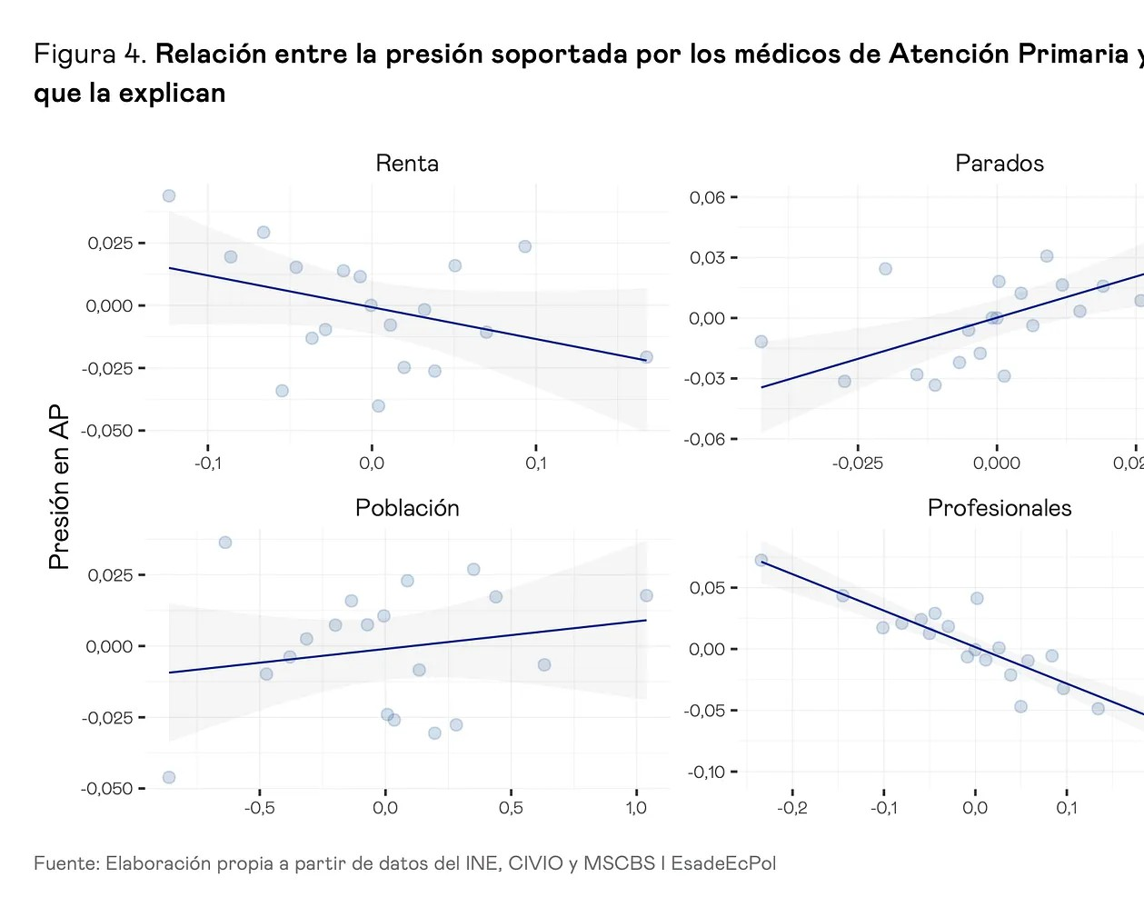

Anyway. If you haven’t seen “El 47,” I encourage you to watch it, and after exploring all its dimensions (which are far more numerous than the specific one I’ve mentioned here), I invite you to think about what concrete steps remain to be taken that would make a real difference for many people.

One of the most vivid memories I have from my childhood was the day I rode the tram for the first time. We were inaugurating Line 4 in Vale. It went as far as Doctor Lluch, a 10-minute walk from my house in Cab, in the spring of 1994, and I was eight years old. It seemed incredible to me—like something out of a civilized city—that something other than a bus would come to my neighborhood. And we were poorly served by buses: lines 1, 2, and 19 went to different parts of the city center, which is less than half the size of Barcelona, with frequencies that weren’t excellent, but decent. But the tram connected me to the northern part of the city: there was the pool where I went swimming, my closest friends, the university where I studied, and my first job in the field of what-I-had-studied. Of course, it meant a major change for the neighborhood. And there’s no doubt that, as a mode of transportation, it reduced emissions on those routes. So, even though we’re not in the half-finished outskirts of 1970s Barcelona, if we look for the physical boundary, we’ll find it. It exists.










1U Likss ∙ 1 Rsstack

